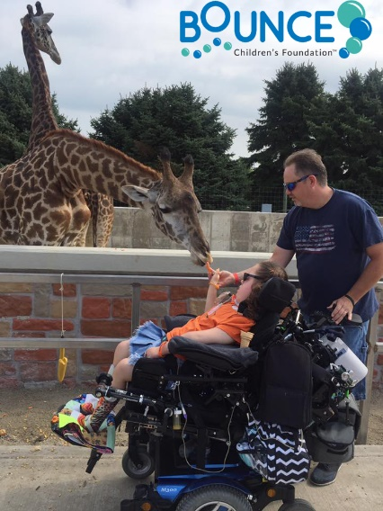
Dear Friend,
Bounce Children’s Foundation™, a Chicagoland not-for-profit, invites you to be part of Buckets for Bounce presented by our Emerging Leaders Board on Saturday, June 17, 2017 at Seward Park in Chicago.
MISSION:
Build community for chronically ill children, and their families,
enabling transformation from surviving to thriving - until cures are found.

Bounce provides support where it is needed most – outside the hospital. Our programs include family adventures, education to build coping skills, access to resources, and focused networking for all because, when a child is diagnosed, the entire family is diagnosed. Bounce builds resilience, brings members together for fun and friendship, and creates happiness, hope, and health for sick kids, their parents, and their siblings.
While many offer their assistance to hospitalized kids, things change once they are home. Kids and families are suddenly on their own. But they still need psycho-social support and ongoing input from experts, as well as inclusion in a community where they can share with, and support, others who walk a similar path. Bounce is unique - it’s the only organization providing this much-needed support, filling a critical gap in the overall care and health of seriously ill kids and their families.
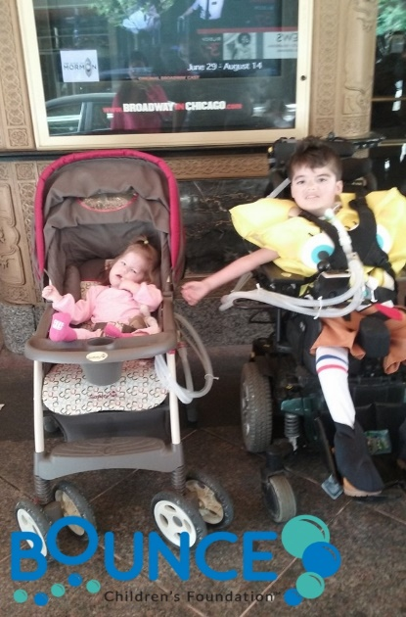
On Saturday, June 17th, 128 players will tip-off for a day of fun and friendly competition, while spectators cheer them on and engage in a variety of games, contests, raffles and activities. All attendees will be entertained by a live band and will have the opportunity to meet those they are helping.
By becoming a sponsor, you will make Bounce available to members who don’t deserve the hand life has dealt them. Your donation is tax-deductible and will be gratefully acknowledged in multiple highly-visible ways. Most importantly, your generosity will enable kids and families to bounce back from the never-ending obstacles and setbacks they face.
Pledge your commitment now and finalize it any time before April 21st.

Sincerely,
Joan M. Steltmann
CEO | Bounce Children’s Foundation

Pete Delneky
Chair | Bounce Emerging Leaders Board

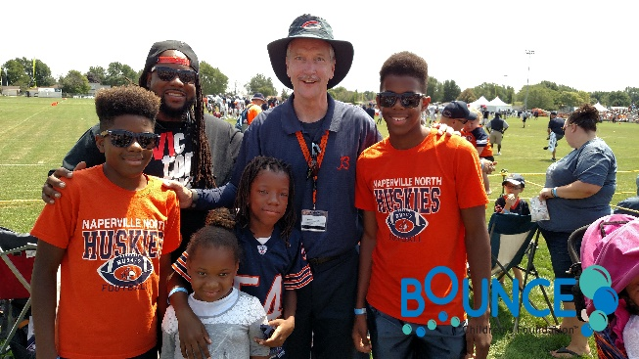
Please complete this form and return via mail or email to:
Bounce Children’s Foundation™
255 Birchwood Ave.
Deerfield, IL 60015
Email: info@bouncechildrensfoundation.org

Sponsor Name (as you wish it to appear): _________________________________________________
Sponsor Contact Person: ______________________________________________________________
Phone: ________________________ Email: ______________________________________________
Address: ___________________________________________________________________________ City/State/Zip:_______________________________________________________________________
Sponsorship Opportunity Selected: _____________________________________________________
- Check enclosed payable to: Bounce Children’s Foundation for $ ___________________________
- Credit Card: o Visa o Mastercard $ ___________________________
Card Number: ________________________________________ Expiration Date: _______ / ________
Name as it appears on card: ________________________________________________ CVV: ______
Billing address: ______________________________________ City/State/Zip: ___________________
Signature: _____________________________________________ Date: ________________________
For more information about sponsorship opportunities, please contact:
Will Weltman, Sponsorship Committee Chair | wweltman@reedsmith.com | 312.207.6551
Carrie Collins | carrie.l.collins@gmail.com | 773.404.4266
Pete Delneky | pete.delneky@cbre.com | 312.935.1478
Mary Lucas | mary.elinor.lucas@gmail.com | 630.288.8954

Thank You Changing the Lives of our Bounce Kids & Families!

Buckets for Bounce Tournament Sponsor: $5,000
ONLY 1 REMAINING!

- 2 Complimentary Tournament 4-person Team Registrations
- 5 Registrations valid for any combination of Half-Court Shot, 3-point Shot or Knock-Out Contests
- Mention in Buckets for Bounce Event Social Media Posts
- Opportunity to include Company Collateral/Item in Player Gift Bags
- Company Logo featured in Premier Location on Event Invitation
(for sponsorship commitments received by 4/14)
- Company Logo Included in Premier location on:
  - Buckets for Bounce Event Sign
  - Event Collateral
  - Event T-Shirt
  - www.BounceChildrensFoundation.org
- Recognition in Bounce Children’s Foundation Monthly E-Newsletter

Half-Court Shot Contest Sponsor: $2,500
SOLD OUT!

- 1 Complimentary Tournament 4-person Team Registration
- 5 Complimentary Registrations for Half-Court Shot Contest
- Company Logo Included in Premier location on Half-Court Contest signage
- Company Logo Included in Prominent location on:
  - Buckets for Bounce Event Sign
  - Event Collateral
  - Event T-Shirt
  - www.BounceChildrensFoundation.org
- Recognition in Bounce Children’s Foundation Monthly E-Newsletter

Kids Zone Sponsor: $1,000
SOLD OUT!

- Company Logo Inclusion in Premier Location on:
  - Kids Arts & Crafts Center Signage
  - VIP Viewing Area for Bounce Families Signage
- Company Logo Inclusion on:
  - Buckets for Bounce Event Sign
  - Event Collateral
  - Event T-Shirt
  - www.BounceChildrensFoundation.org
- Recognition in Bounce Children’s Foundation Monthly E-Newsletter

3-Point Shot Contest Sponsor: $1,000 SOLD OUT!
- 2 Complimentary Registrations for 3-Point Shot Contest
- Company Logo Inclusion in Premier Location on 3-Point Contest Signage
- Logo Inclusion on:
  - Buckets for Bounce Event Sign
  - Event Collateral
  - Event T-Shirt
  - www.BounceChildrensFoundation.org
- Recognition in Bounce Children’s Foundation Monthly E-Newsletter

Knock-Out Contest Sponsor: $1,000 SOLD OUT!

- 2 Complimentary Registrations for Knock Out Contest
- Company Logo Inclusion in Premier Location on Knock Out Contest Signage
- Company Logo Inclusion on:
  - Buckets for Bounce Event Sign
  - Event Collateral
  - Event T-Shirt
  - www.BounceChildrensFoundation.org
- Recognition in Bounce Children’s Foundation Monthly E-Newsletter

Spectator Seating Sponsor: $1,000 SOLD OUT!

- 2 Registrations valid for any combination of Half-Court Shot, 3-point Shot or Knock-Out Contests
- Company Logo Inclusion in Premier Location on Bleacher Signage
- Company Logo Inclusion on:
  - Buckets for Bounce Event Sign
  - Event Collateral
  - Event T-Shirt
  - www.BounceChildrensFoundation.org
- Recognition in Bounce Children’s Foundation Monthly E-Newsletter

Fan Food Zone: $1,000
SOLD OUT!
- 2 Registrations valid for any combination of Half-Court Shot, 3-point Shot or Knock-Out Contests
- Company Logo Inclusion in Premier Location on Fan Food Zone Signage
- Company Logo Inclusion on:
  - Buckets for Bounce Event Sign
  - Event Collateral
  - Event T-Shirt
  - www.BounceChildrensFoundation.org
- Recognition in Bounce Children’s Foundation Monthly E-Newsletter
Player Check-In Corner: $1,000
SOLD OUT!
- 2 Registrations valid for any combination of Half-Court Shot, 3-point Shot or Knock-Out Contests
- Company Logo Inclusion in Premier Location on Player Check-In Corner Signage
- Company Logo Inclusion on:
  - Buckets for Bounce Event Sign
  - Event Collateral
  - Event T-Shirt
  - www.BounceChildrensFoundation.org
- Recognition in Bounce Children’s Foundation Monthly E-Newsletter

Bag Toss Game Sponsor: $500
ONLY 2 REMAINING!

- Company Logo Inclusion in Premier Location on one set of Bag Toss Game Boards
- Company Logo Inclusion on:
  - Buckets for Bounce Event Sign
  - Event Collateral
  - www.BounceChildrensFoundation.org
- Recognition in Bounce Children’s Foundation Monthly E-Newsletter

Life-Size Jenga Game Sponsor: $500
SOLD OUT!

- Company Logo Inclusion in Premier Location on Life-Size Jenga Game Signage
- Company Logo Inclusion on:
  - Buckets for Bounce Event Sign
  - Event Collateral
  - www.BounceChildrensFoundation.org
- Recognition in Bounce Children’s Foundation Monthly E-Newsletter

